Assignment No 13
Problem Statement:
Create a WorkMail for your organization.
Solution:
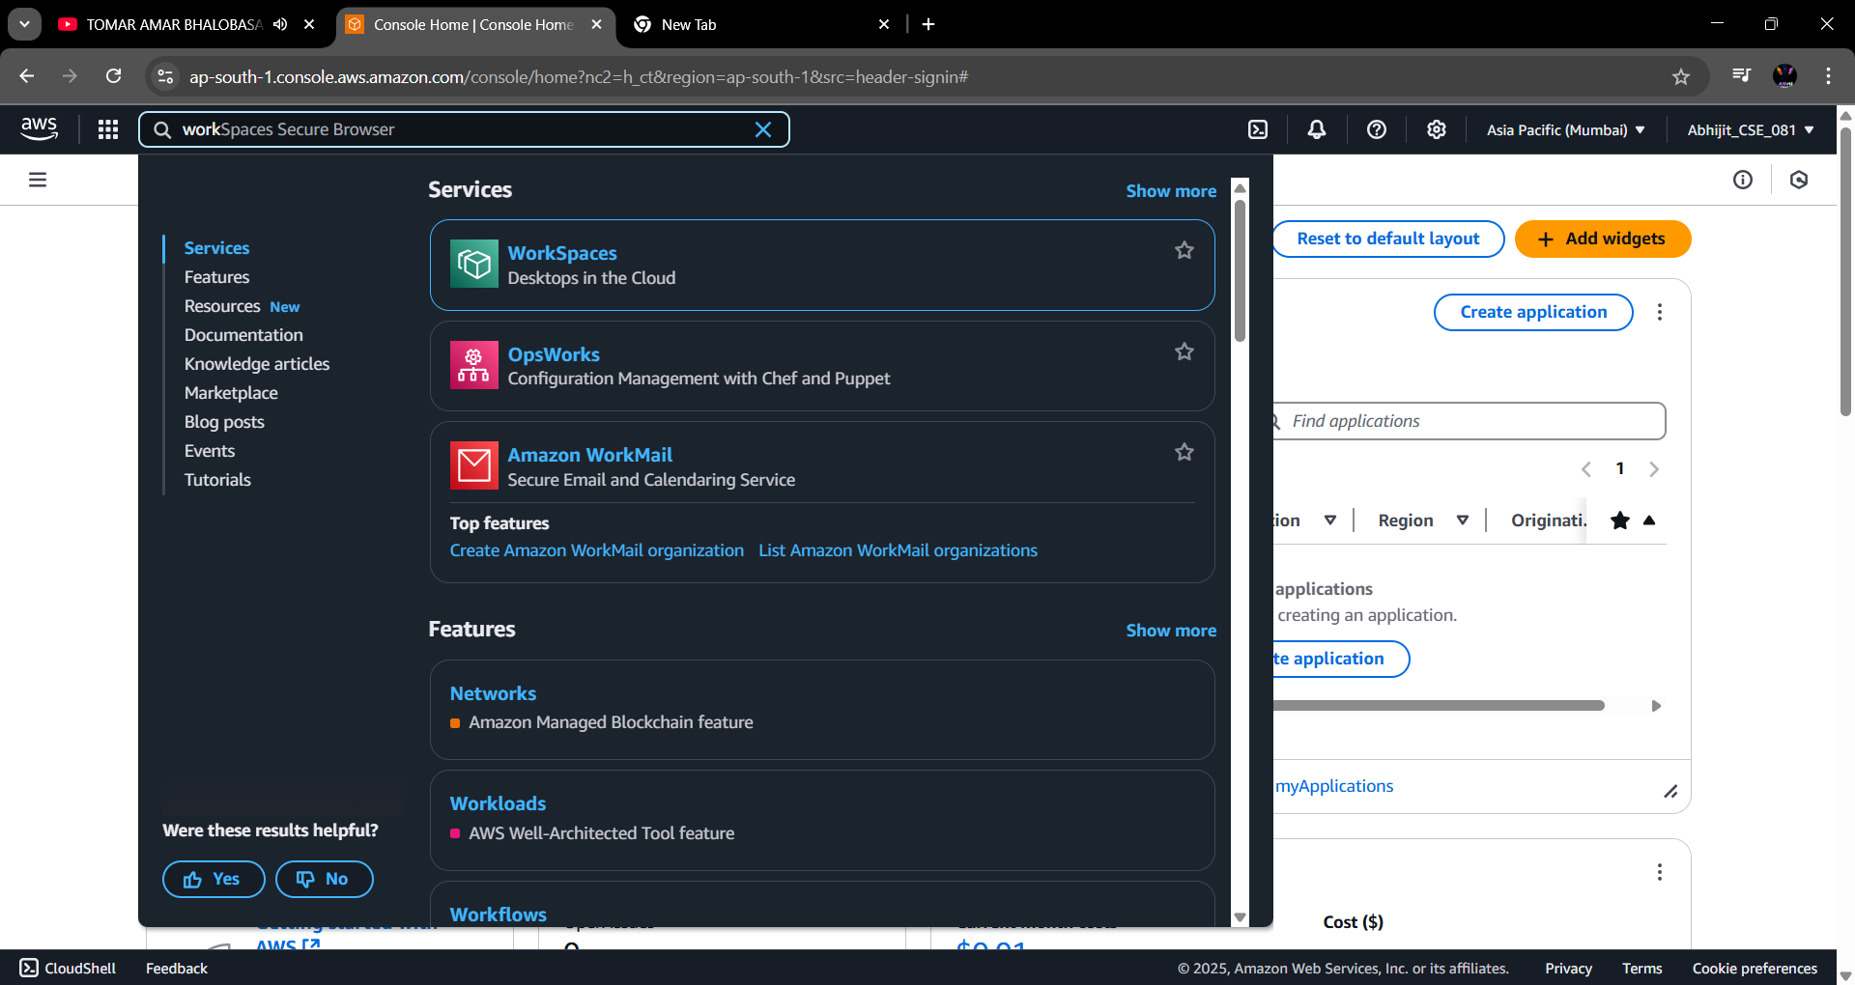
Step 1: Search for “Amazon WorkMail” in the search bar & open it.

Step 2: Click on “Create Organization”.
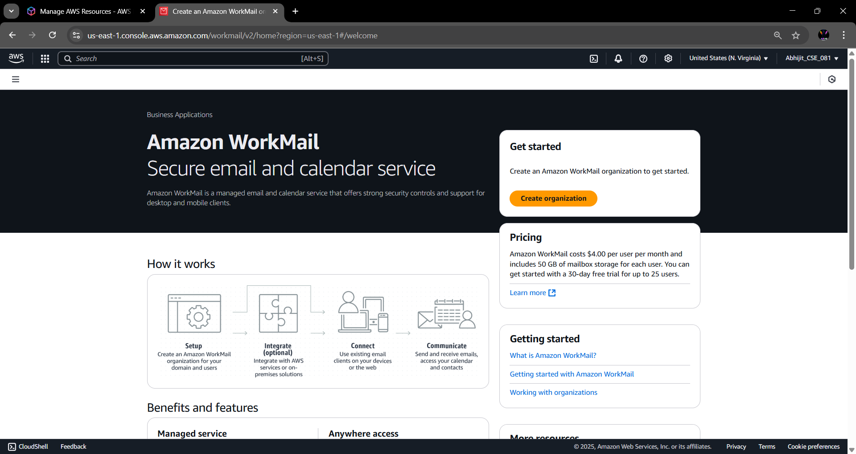
Step 3: Under Organization settings select “Free Test Domain”. Give the organization name under alias. Then click on “Create Organization”.
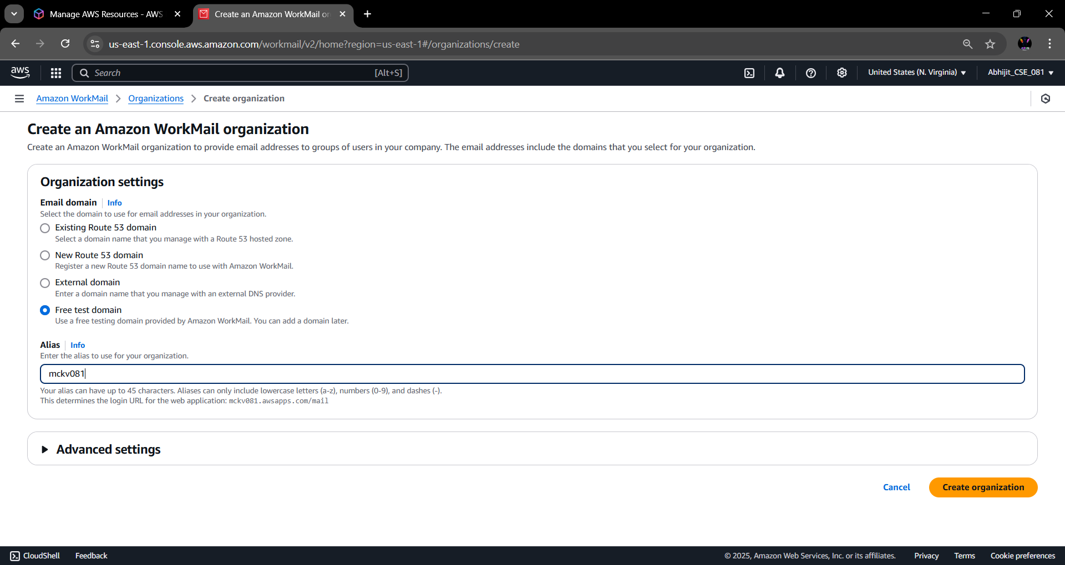

Step 4: The organization is created successfully. Click on the organization name to enter into it.
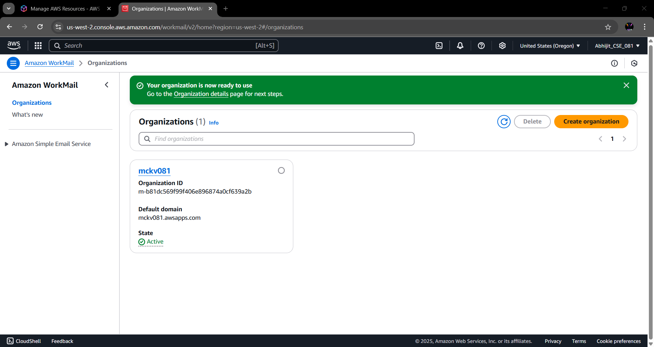Step 5: From the left side menu, go to the “Users” option under Organization.
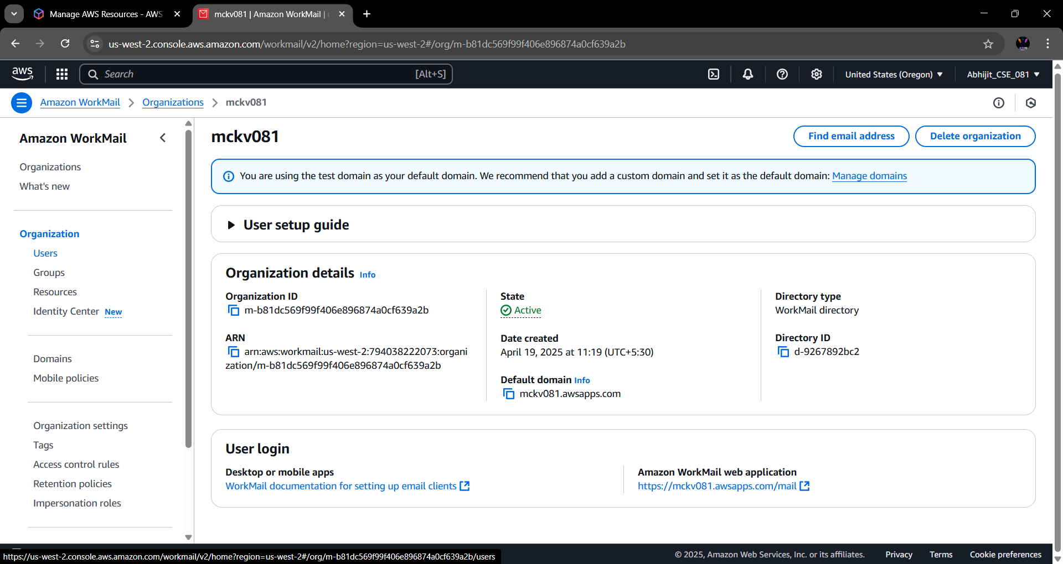
Step 6: Click on “Add User” button.
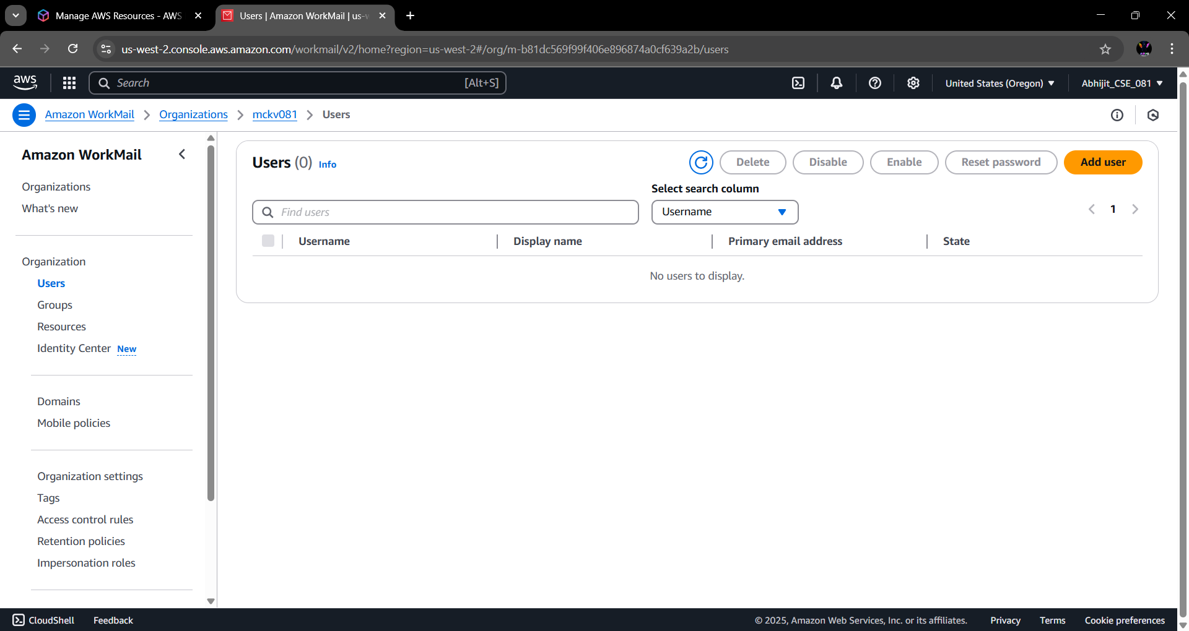

Step 7: Fill basic user details.
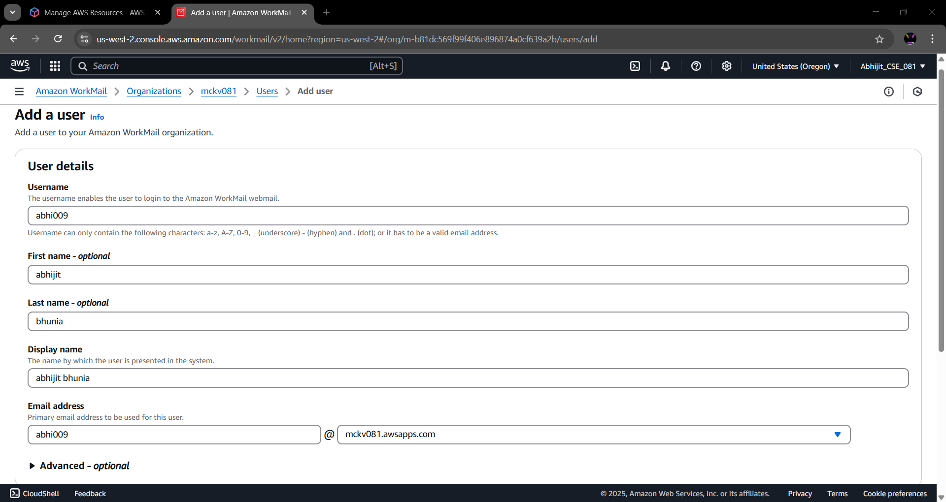
Step 8: Set up a password. Then click on “Add User”.
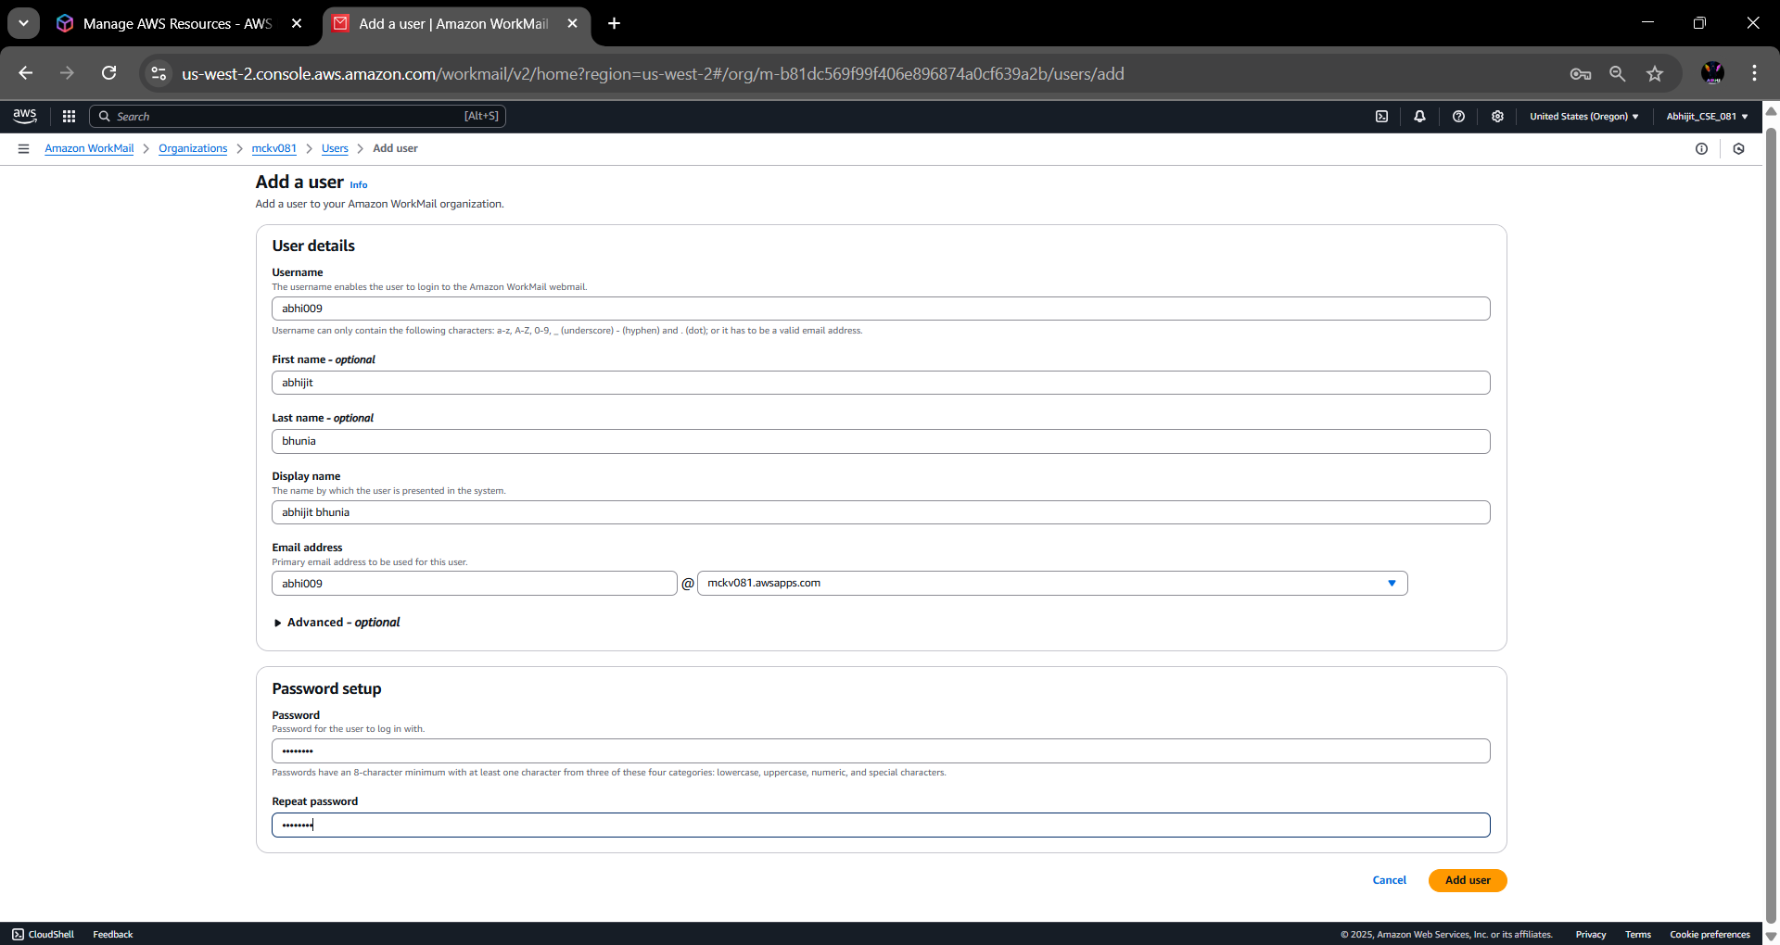
Step 9: The user is successfully created. Now, go back enter into Organization.
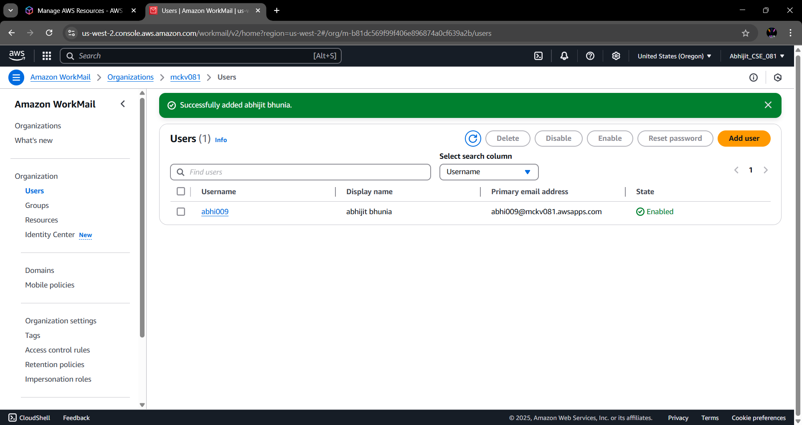

Step 10: From the bottom of the screen, click on the “Amazon WorkMail Web Application” link.
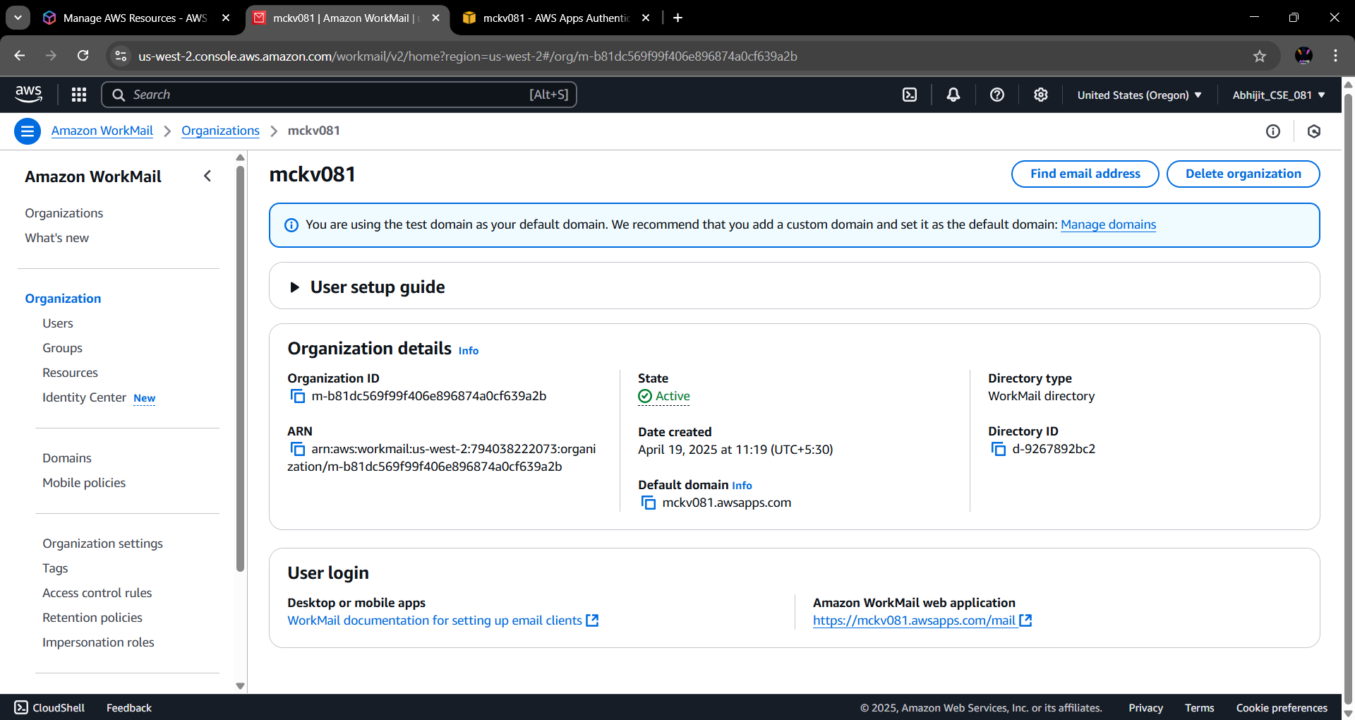
Step 11: Login into the Amazon WorkMail with ‘User Name’ and ‘Password’.
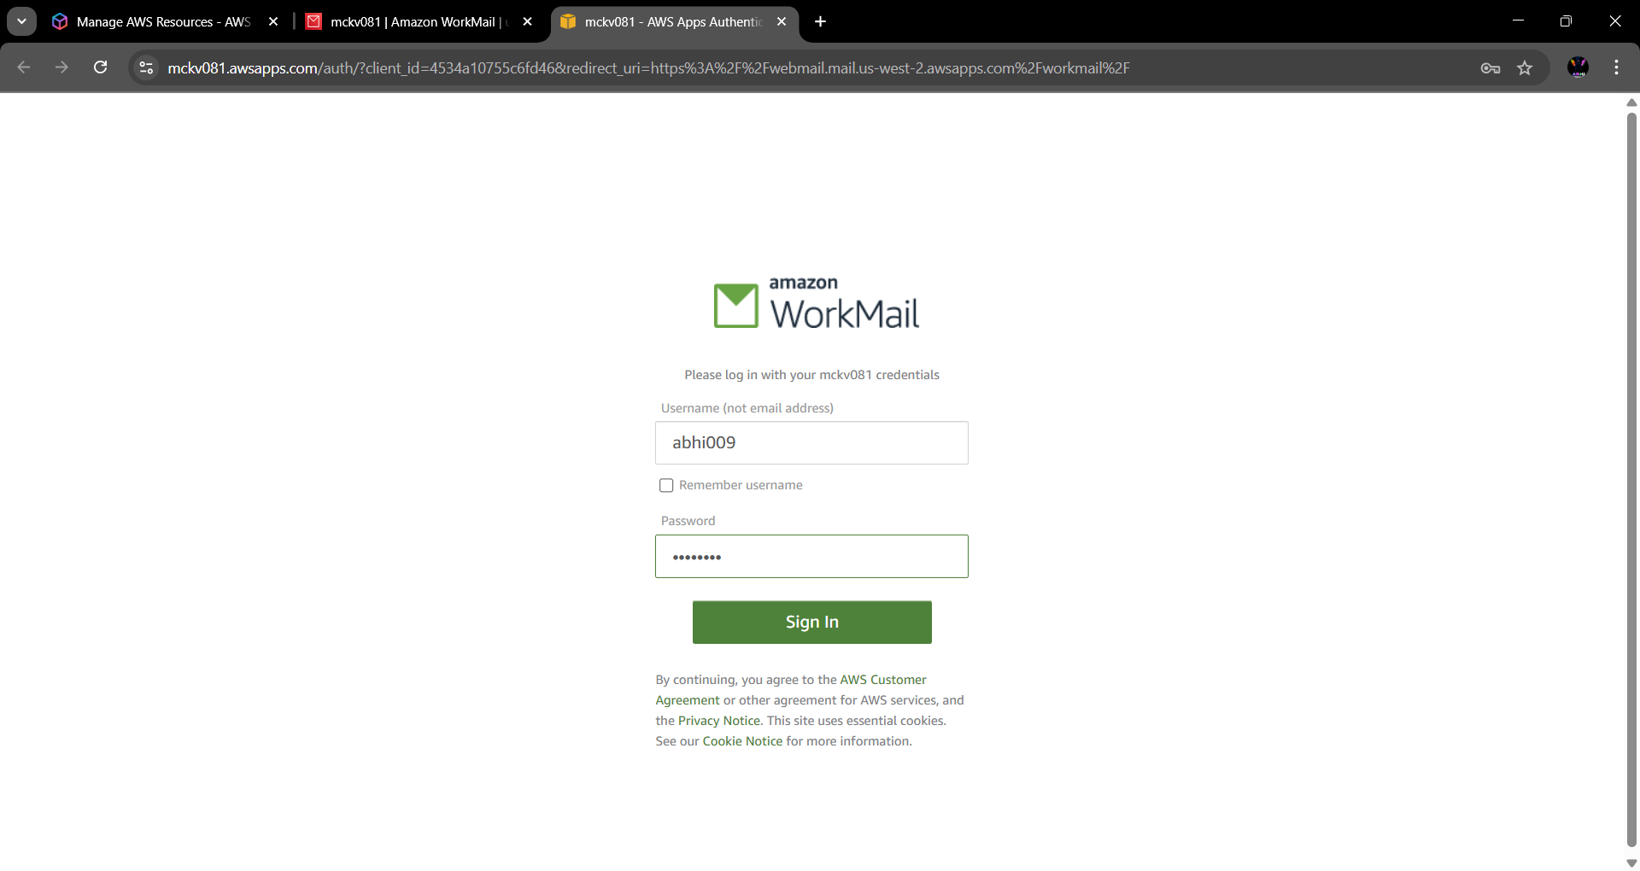

Step 12: In AWS WorkMail, click on ‘New item’ section choose ‘New Email’. Composed A new workmail with ‘Receiver Email Address’ and write something in the mail body. Finally click on ‘Send’ option.
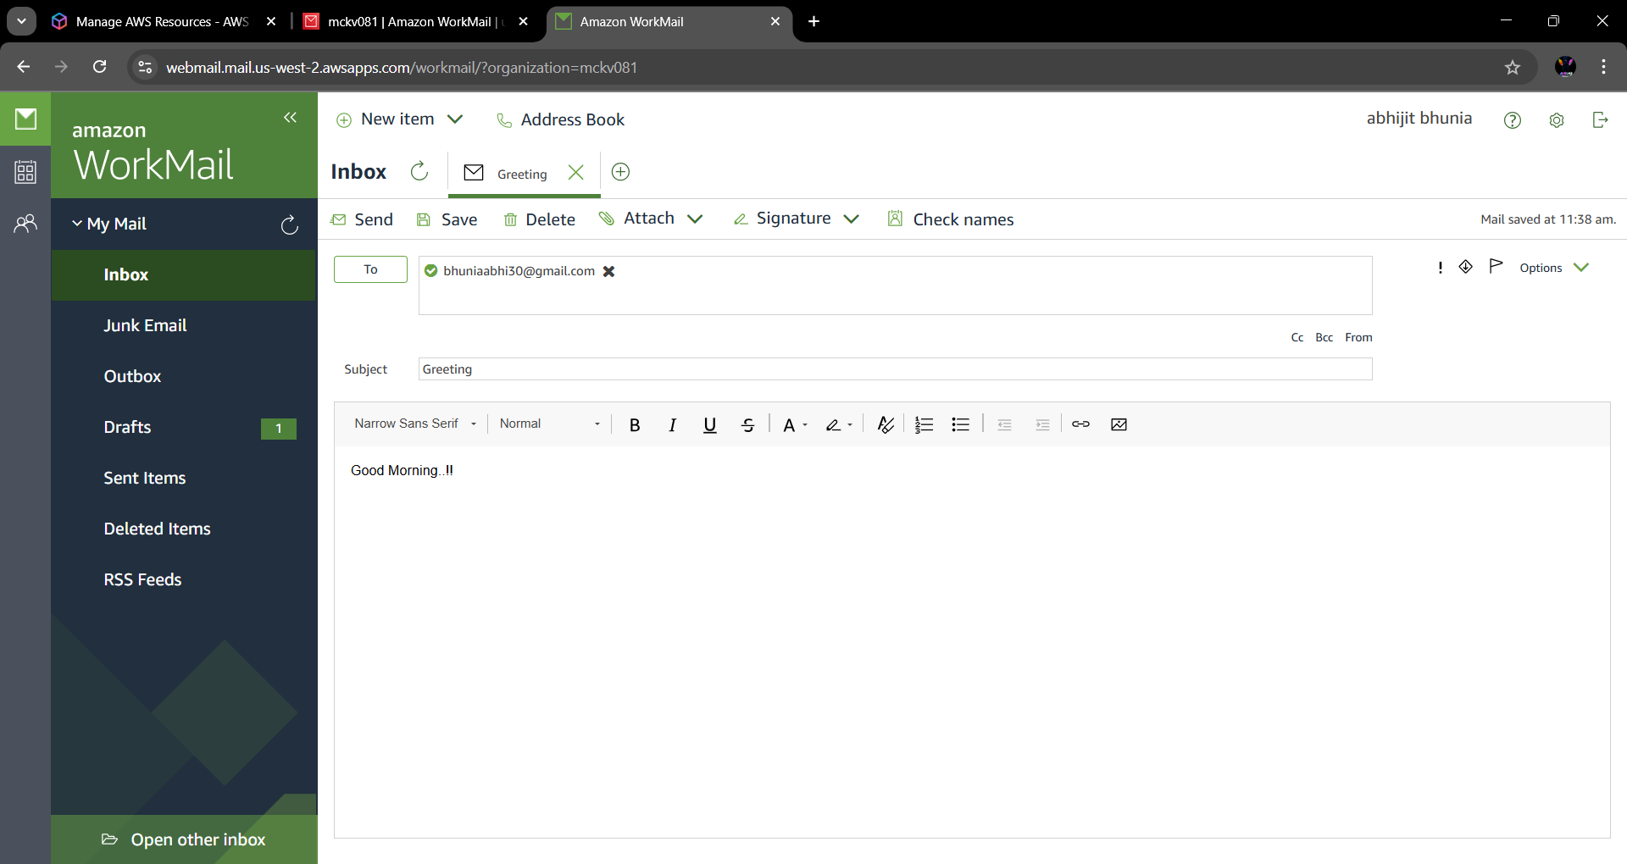
Step 13: Now in Receiver end workmail is received successfully.
